**Article title**: Micro Behavior: A New Perspective in E-commerce Recommender System

**Link**: <https://sci-hub.tw/10.1145/3159652.3159671>

**Summary**: studying customer’s micro behaviors (reading comments, carting, ordering, how long the user stays with the item) helps us better understand about the user and better for recommending products. When suggesting the right products to consumers it increases their satisfaction and create customer loyalty as well as improve revenue and growth.[1]

**Types of data we need:**

Collecting a dataset from a site in a given period for each customer that contains information such as:

* **Click source:** the entrance to a product page, how did they get to this page, what was the previous page (home = just browsing , search bar = stronger intent to buy)
* **Browsing modules:** different browsing modules (name, price, thumbnail picture, comments, specification) can indicate the user’s interests (browsing comments = strong intent to buy, brief description = less intent to buy)
* **Cart and order:** strong signal for recommendations and buying a product. Ordering can mean high potential for re-purchase such as snacks. But if a consumer buys a TV, she is less likely to buy another one soon
* **Dwell time:** adopted to measure the importance of a webpage on a search engine. (higher time = higher interests)

*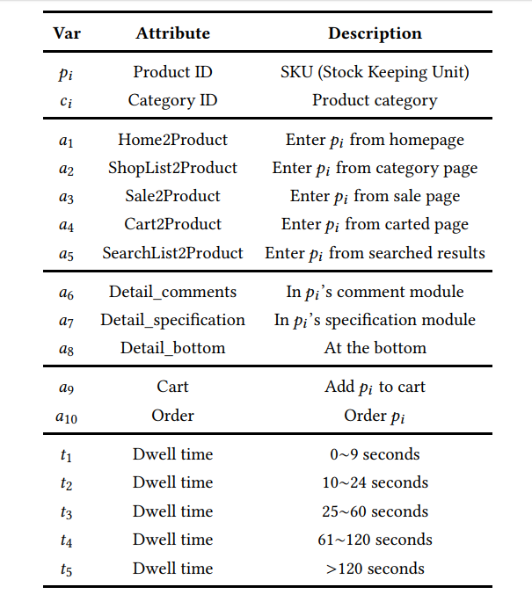p* = products

*a* = activities

*d* = dwell time

1. ] Chenyan Xu, Daniel Peak, and Victor Prybutok. 2015. A customer value, satisfaction, and loyalty perspective of mobile application recommendations. Decision Support Systems 79 (2015), 171–183.